**LITESOPH INSTALL GUIDE**

**Prerequisites:**

* Linux System (Ubuntu recommended)
* Miniconda
* Litesoph Dependencies

**Step 1 - First install miniconda**

open the terminal start by typing these commands to install miniconda

mkdir -p ~/miniconda3

wget https://repo.anaconda.com/miniconda/Miniconda3-latest-Linux-x86_64.sh -O ~/miniconda3/miniconda.sh

bash ~/miniconda3/miniconda.sh -b -u -p ~/miniconda3

~/miniconda3/bin/conda init bash

Or you can refer this link if you want to know how to install

[https://docs.conda.io/projects/miniconda/en/latest/index.html#quick-command-line-install](https://docs.conda.io/projects/miniconda/en/latest/index.html%23quick-command-line-install)

**Step 1.1 - Create a conda environment**

conda create -n myenv

conda create -n litesoph -- I have named this as my environment

conda activate litesoph -- to activate the environment

**STEP 2 – Install Software Dependencies**

1. NWCHEM
2. GPAW
3. Octopus

GPAW and NWCHEM

To install GPAW and NWChem in the same conda environment

conda install -c conda-forge gpaw nwchem python=3.10

OCTOPUS INSTALL

To install octopus you need to install spack first so do these steps

git clone -c feature.manyFiles=true https://github.com/spack/spack.git

source spack/share/spack/setup-env.sh

Note - You need to have a gcc and gfrotran compilers so check versions

gcc - - version

gfortran - -version

Your compilers file should look like this

spack install octopus

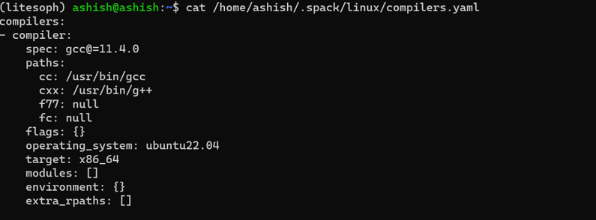

**STEP 3 - LITESOPH**

You can get the source code from the following command

• git clone -b main <https://github.com/aitgcodes/litesoph.git>

• cd litesoph

• pip install .

**To edit the file**

To create Isconfig file: litesoph config -c

To edit Isconfig file: litesoph config -e

**STEP 3.1 - How to use the software**

use command

• litesoph gui

